Review and Evaluation

Cullen Martin UserId: 19026648

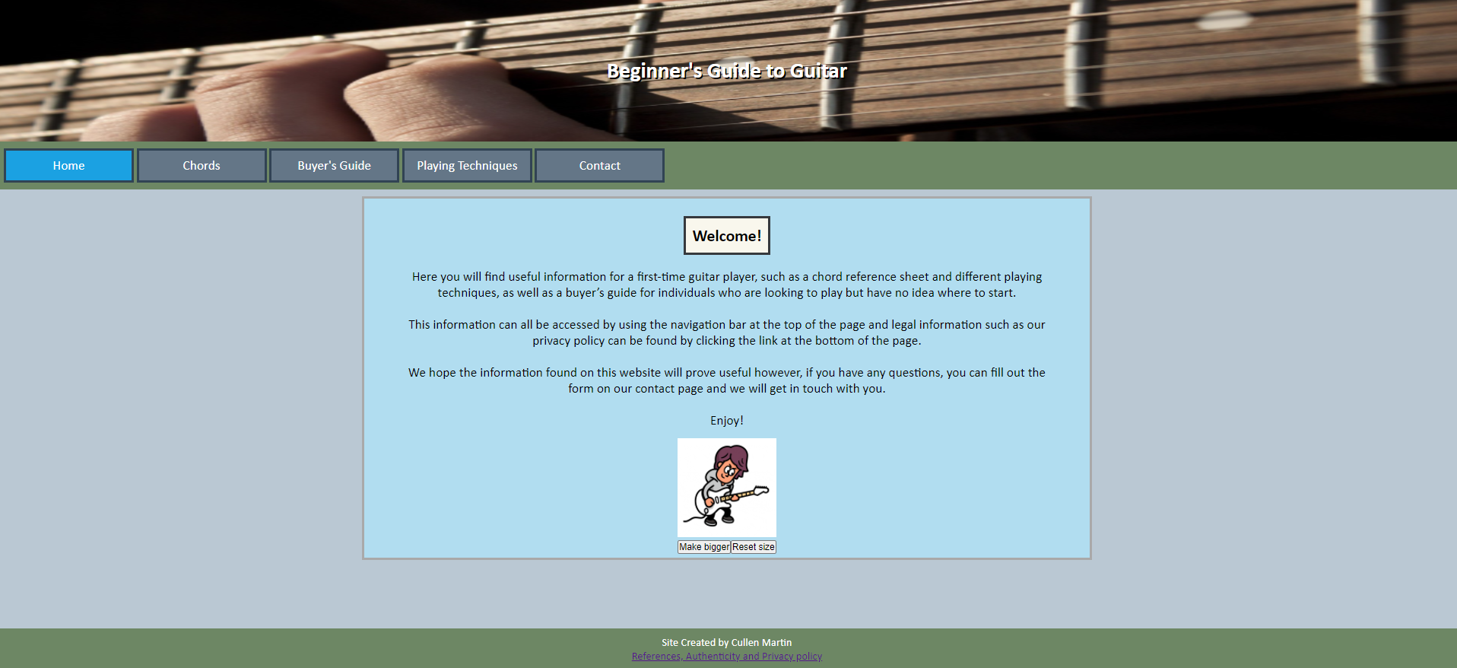

The first thing that I changed from my original design was the visual presentation of the “Chords” and “Playing techniques” pages. My original design had three separate boxes for each of the topics covered on those pages, while my new design houses all three on one. I chose this new layout as I felt, especially with the “Chords” page, that splitting the page into three separate boxes was unnecessary since two of these boxes just housed images with no text other then the heading. I feel that the new design Improved readability by reducing clutter. My second change was the addition of a contact form on my “Contact” page. Originally this page was going to display a short paragraph of contact information, however I feel that my change added another aspect of interactivity to the site as opposed to just reading information. The addition of a “References, Authenticity and Privacy policy” page was my third major change. This page was overlooked in the original design and adding it ensures that visitors to my site know how their data may be collected, stored, and used while the references section ensures that credit is given to the people who own the images, videos, and music I used on the site.

To improve upon the website, I would have liked to add a way of storing the information submitted on my contact form. The reason This was not added on the final website was due to the limitations of my knowledge on data collection and storage from a coding perspective.

* Identify 3 problems during dev phase and how I overcame them
* For the video that is displayed on my “buyer’s guide” page, I had difficulty using a downloaded mp4 video and so I chose to use a YouTube video instead as suggested by the assignment brief.
* There were a couple of times where I had difficulty with my HTML code not working as intended. In an effort to fix these issues I consulted my peers on the BCS discord server for advice which I found very helpful and allowed me to continue with my project.
* On mobile screens I had issues where the pages content would overflow. In order to solve this issue, I ensured that the section of the page that housed its content did not have a fixed height, allowing it to adjust based on the size of the viewport. I also added media queries to adjust the font size and width of the page’s content for easier viewing on smaller screens. The “Chords” and “Playing techniques” pages also change from a column-based flex direction to row-based to avoid this issue.

I am honestly surprised with how much I learned during this course, now having a basic understanding of HTML, CSS, and JavaScript. Before taking this course, I only had limited experience with python 3. While I did feel a little overwhelmed in the first couple of weeks, I am fairly happy with where I am now with my knowledge of the aforementioned programming languages.

I have nothing to say for improving the course itself, however I feel that placing this course in the same term as the Programming Fundamentals course meant that students needed to learn four different programming languages at the same time which personally left me feeling overwhelmed at times.

During this course I found the w3schools website to be immensely helpful for whenever I was at home stuck on an issue with my code.